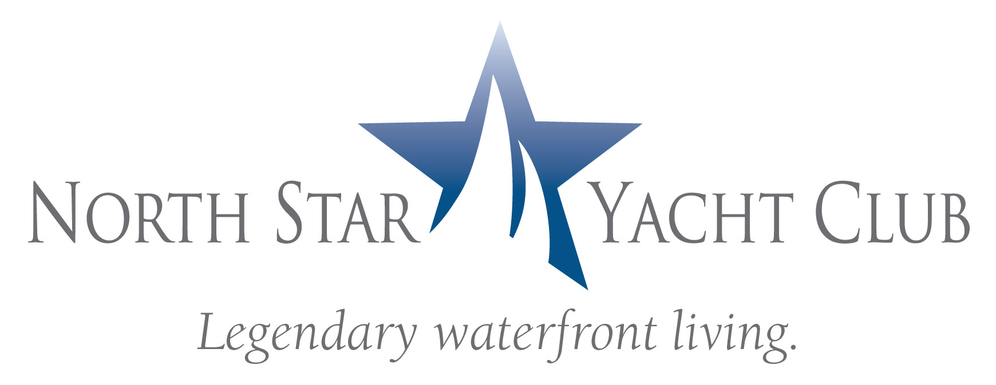

FOR IMMEDIATE RELEASE

FIRST ANNUAL RIVER DISTRICT REGATTA TROPHY PRESENTED

North Star Yacht Club Donates $4250 to Edison Sailing Center

FORT MYERS, Fla. – July 23, 2008 – An award ceremony, commemorating the inaugural River District Regatta, was held at North Star Yacht Club July 18. North Star Yacht Club, which served as the event’s host and primary sponsor, will proudly display the regatta trophy.

The First Annual Open Invitational River District Regatta, organized by the Fort Myers Sailing Club as a fundraiser for the Edison Sailing Center, was held May 3. The one-day regatta featured three sailboat races along the Caloosahatchee River, between the Caloosahatchee and Midpoint Bridges. The event also included a fine art show, wine tasting and silent auction that raised $4250, which North Star Yacht Club donated to the Edison Sailing Center.

Established in 1984, Edison Sailing Center teaches Southwest Florida youth to develop personal skills, sportsmanship, independent thinking and self-confidence while on the water. Complete information is available on-line at www.edisonsailingcenter.org.

North Star Yacht Club, a gated condominium community situated on 12-acres along the Caloosahatchee River, offers luxury waterfront living and resort-style amenities including boat slips. North Star Yacht Club is located at 3420 Hancock Bridge Parkway in North Fort Myers. For more information, go to www.northstaryachtclub.com.

###

